***Over View of framework***

***Framework Structure:*** *Page Object Model*

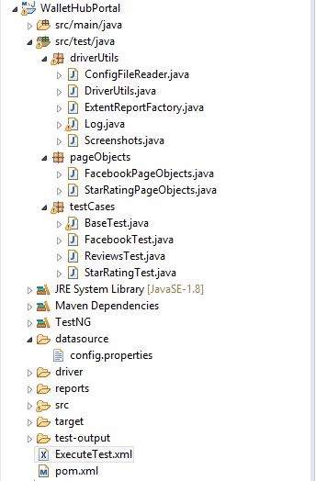

***src/test/java***

* ***Driver utils***
* ***Page objects***
* ***Test cases***

***POM.* Xml – Added dependencies**

**config.properties –**

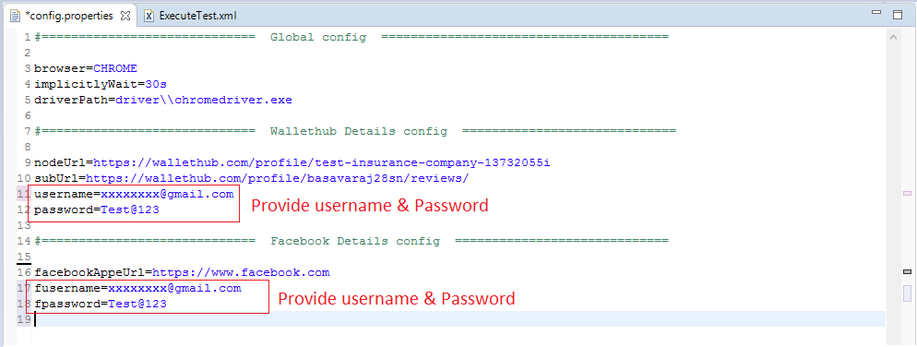

**ExecuteTest.xml > RunAs TestNG Suite**

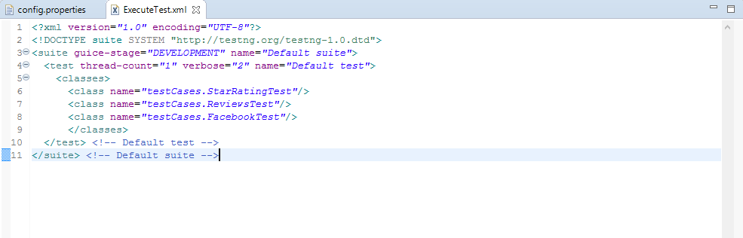

**Reports: Extent report**

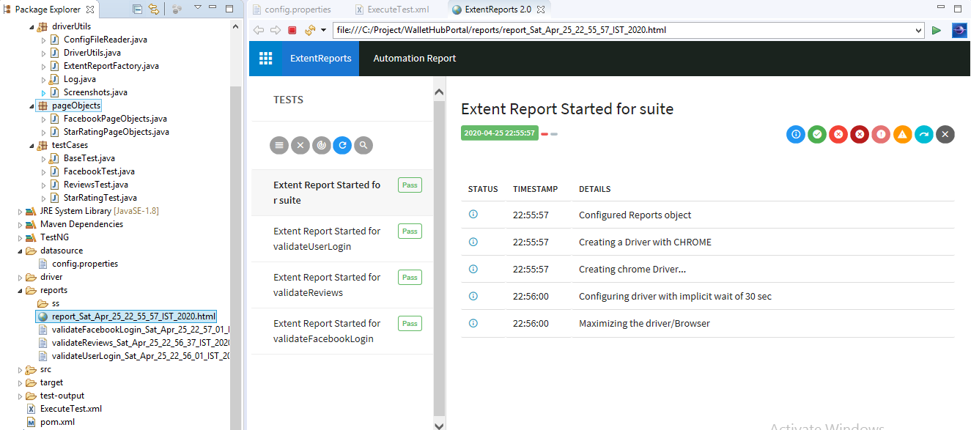

**Reports Logs**

